|  |  |
| --- | --- |
| Assignment No. | 1 |
| Name | LAKSHMI PRIYA B |
| Registration No. | 921319104104 |
| Batch No. | B7-1A3E |

# Question-1:

**Create registration page in html with username, email, and phone number and by using POST method display it in next html page.**

# index.html

<!DOCTYPE html>

<html>

<head>

<meta charset="utf-8">

<meta name="viewport" content="width=device-width, initial-

scale=1">

<title>Registration</title>

<link rel="stylesheet" href="{{

url_for('static',filename='styles/index.css') }}">

</head>

<body>

<center>

<br><br>

<h1>Registration</h1><br>

<form action="{{ url_for('result') }}" method="post">

<table>

<tr>

<td>

</td>

<td>

<label>Name</label>

: <input type="text" class="name-input

name mb-3" id="name" name="name">

</td>

</tr>

<tr>

<td>

</td>

<td>

<label>Email</label>

: <input type="email" class="name-

input name mb-3" id="email" name="email">

</td>

</tr>

<tr>

<td>

</td>

<td>

<label>Mobile</label>

: <input type="number" class="name-

input name mb-3" id="mobile" name="mobile">

</td>

value="Submit">

</tr>

</table>

<br><br>

<input class="btn btn-outline-primary" type="submit"

</form>

</center>

</body>

</html>

# result.html

<!DOCTYPE html>

<html>

<head>

<meta charset="utf-8">

<meta name="viewport" content="width=device-width, initial-

scale=1">

<title>Profile</title>

<link rel="stylesheet" href="{{

url_for('static',filename='styles/index.css') }}">

</head>

<body>

<center>

<br><br>

<h1>Welcome !!!</h1>

<br>

<form action="{{ url_for('result') }}" method="post">

<table>

<tr>

</tr>

<tr>

</tr>

<tr>

<h3>Name : {{ name }}<br></h3>

<h3>Email : {{ email }}<br></h3>

<h3>Mobile : {{ mobile }}<br></h3>

</tr>

</table>

<br><br>

</form>

</center>

</body>

</html>

# app.py

from flask import *; import os

app = Flask( name )

@app.route('/', methods=['GET', 'POST']) def home():

if request.method == 'POST': name = request.form["name"] email= request.form["email"]

mobile = request.form["mobile"]

return redirect(url_for('result', name=name, email=email, mobile=mobile))

return render_template('index.html')

@app.route("/result", methods=['GET', 'POST']) def result():

name = request.form.get('name') email= request.form.get('email') mobile = request.form.get('mobile')

return render_template('result.html', name=name, email=email, mobile=mobile)

if name == " main ": app.run(debug=True, port=2807)

# OUTPUT:



**Question-2:**

# Develop a Flask program which should contain at least 5 packages used from pypi.org

*#1. NUMPY*

import numpy as np

arr = np.array([[-1, 2, 0, 4],

[4, -0.5, 6, 0],

[2.6, 0, 7, 8],

[3, -7, 4, 2.0]])

print("Initial Array: ") print(arr)

Initial Array:

[[-1. 2. 0. 4. ]

[ 4. -0.5 6. 0. ]

[ 2.6 0. 7. 8. ]

[ 3. -7. 4. 2. ]]

*#2. PANDAS*

import pandas as pd

s1 = pd.Series([1, 3, 4, 5, 6, 2, 9])

s2 = pd.Series([1.1, 3.5, 4.7, 5.8, 2.9, 9.3])

s3 = pd.Series(['a', 'b', 'c', 'd', 'e']) Data ={'first':s1, 'second':s2, 'third':s3}

df = pd.read_csv('/content/sample_data/ds_salaries.csv') print(df)

|  |  |  |  |  |  |
| --- | --- | --- | --- | --- | --- |
|  | Unnamed: 0 | work_year | experience_level | employment_type | \ |
| 0 | 0 | 2020 | MI | FT |  |
| 1 | 1 | 2020 | SE | FT |  |
| 2 | 2 | 2020 | SE | FT |  |
| 3 | 3 | 2020 | MI | FT |  |
| 4 | 4 | 2020 | SE | FT |  |
| .. | ... | ... | ... | ... |  |
| 602 | 602 | 2022 | SE | FT |  |
| 603 | 603 | 2022 | SE | FT |  |
| 604 | 604 | 2022 | SE | FT |  |
| 605 | 605 | 2022 | SE | FT |  |
| 606 | 606 | 2022 | MI | FT |  |

job_title salary salary_currency salary_in_usd

\

1. Data Scientist 70000 EUR 79833
2. Machine Learning Scientist 260000 USD 260000
3. Big Data Engineer 85000 GBP 109024

|  |  |  |  |  |  |  |  |
| --- | --- | --- | --- | --- | --- | --- | --- |
| 3 | Product Data Analyst | | 20000 | | USD | | 20000 |
| 4 | Machine Learning Engineer | | 150000 | | USD | | 150000 |
| .. | ... | | ... | | ... | | ... |
| 602 | Data Engineer | | 154000 | | USD | | 154000 |
| 603 | Data Engineer | | 126000 | | USD | | 126000 |
| 604 | Data Analyst | | 129000 | | USD | | 129000 |
| 605 | Data Analyst | | 150000 | | USD | | 150000 |
| 606 | AI Scientist | | 200000 | | USD | | 200000 |
|  | employee_residence | remote_ratio | | company_location | | company_size | |
| 0 | DE | 0 | | DE | | L | |
| 1 | JP | 0 | | JP | | S | |
| 2 | GB | 50 | | GB | | M | |
| 3 | HN | 0 | | HN | | S | |
| 4 | US | 50 | | US | | L | |
| .. | ... | ... | | ... | | ... | |
| 602 | US | 100 | | US | | M | |
| 603 | US | 100 | | US | | M | |
| 604 | US | 0 | | US | | M | |
| 605 | US | 100 | | US | | M | |
| 606 | IN | 100 | | US | | L | |

[607 rows x 12 columns]

*#3. SEABORN*

import seaborn as sns

sns.pairplot(df,hue="salary",height=3)

<seaborn.axisgrid.PairGrid at 0x7f32024d5650>

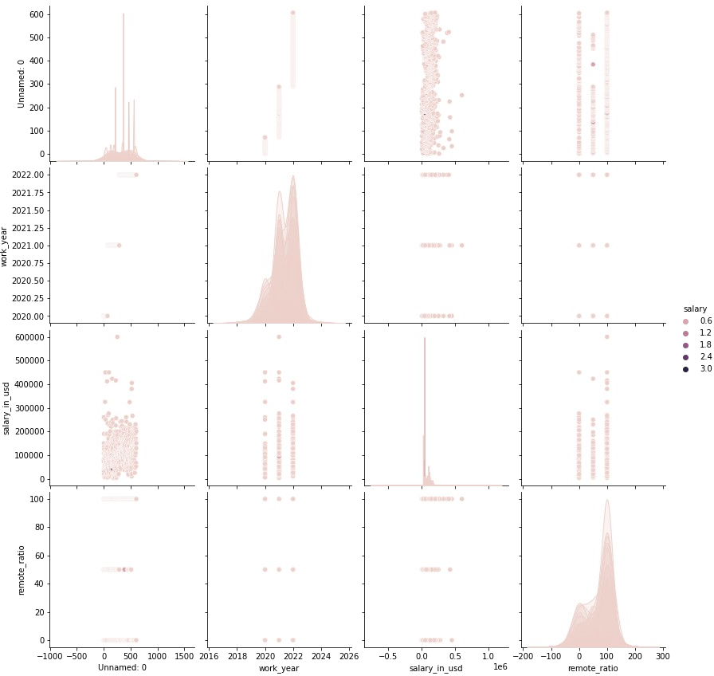

*#4. TENSORFLOW*

import tensorflow as tf

mnist = tf.keras.datasets.mnist

(x_train, y_train), (x_test, y_test) = mnist.load_data() x_train, x_test = x_train / 255.0, x_test / 255.0

model = tf.keras.models.Sequential([ tf.keras.layers.Flatten(input_shape=(28, 28)), tf.keras.layers.Dense(128, activation='relu'), tf.keras.layers.Dropout(0.2), tf.keras.layers.Dense(10)

])

*#5. PYTZ*

from pytz import timezone from datetime import datetime

format = "%Y-%m-%d %H:%M:%S %Z%z"

now_utc = datetime.now(timezone('UTC')) print(now_utc.strftime(format))

now_asia = now_utc.astimezone(timezone('Asia/Kolkata')) print(now_asia.strftime(format))

2022-10-07 16:36:09 UTC+0000

2022-10-07 22:06:09 IST+0530